Analysis of the performance of activation functions on image classifier convolutional neural networks
Lucas Hattori Costa
Polytechnic School of Engineering – University of São Paulo
lucashattori@usp.br

Objective
The use of convolutional neural networks (CNN) applied to Pattern Recognition and Computer Vision has been consolidated and heavily deepened in the past decades. Aiming to solve problems such as time spent, computational power envolved and others, many researches were made about the features of differents activations functions when those were applied to differents types of datasets. The present study is based on analysing the performance, features and differences between activation functions in a CNN that classifies images of LIBRAS representations. The activation functions addressed are the ReLU (Rectified Linear Unit) and its parameterized version, sigmoid or logistic function, ELU (Exponential Linear Unit) and softmax..
Materials and Methods
In order to make the comparison between the functions, Python and framework Keras were utilised with a TensorFlow back-end. The functions were implemented as concepted in the framework utilised. The remaining parameters of the CNN were used equally for each function. The used dataset contains, initially, 9074 colorful images of LIBRAS representations. The data augmentation process consists in transforming the images into gray-scale ones, resizing and rotating the images 180 degrees horizontally.

Results
The functions performance are comparable in many aspects of the network. Among those, one of the most expressive is the validation accuracy, for it shows the software’s effectiveness. The Picture I represents the functions performance in that aspect.
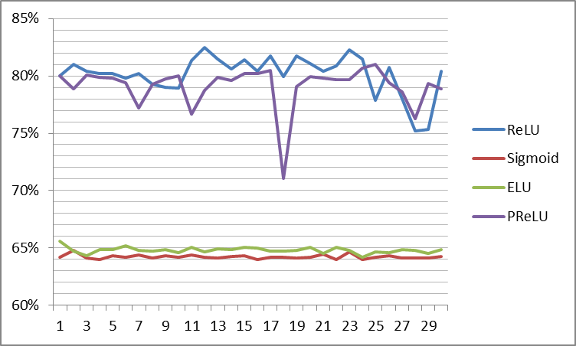
Picture 1: Validation accuracy of functions ReLU, Sigmoid, ELU and PReLU.
Conclusions
In each aspect analised, there is a optimal function to be used. In the matter of validation accuracy, as shown, the best one is the ReLU and its parameterized version..
References
ZHANG, C.; WOODLAND, P.C. Parameterised Sigmoid and ReLU Hidden Activation Functions for DNN Acoustic Modelling.
KAIMING, H; JIAN, S. Convolutional Neural Networks at Constrained Time Cost.

